Micro Perforator to fit Morgana machines
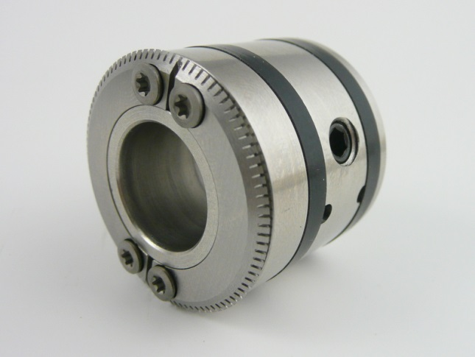
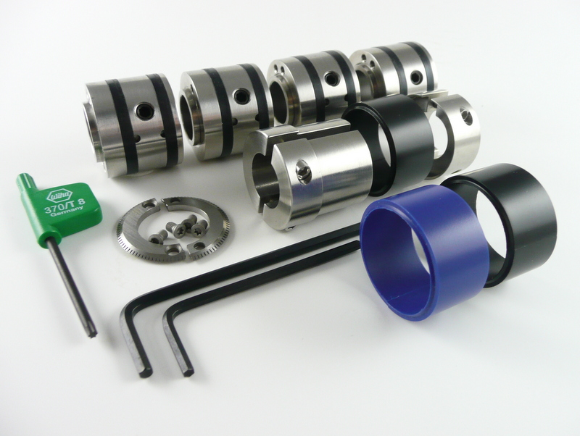
with a 15mm exit shaft
The basic working principle of the micro perforator is to run a special hardened perforation blade on to the surface of a nylon sleeve to produce an almost invisible and flat perforated sheet.

The 4 x top shaft support collars not only grip and stabilise the sheet they can be also used to mount 2 halves of a perforation blade on to the side wall.
Each perforation blade is a unique, matching precision fit and should never be mixed with any other blade.
4 x T8 Hardened Torx screws hold the blade to the support collar by using the green Torx Key shown below.

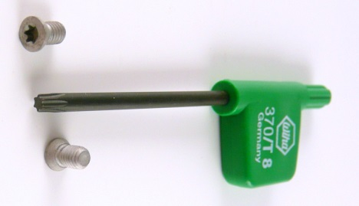

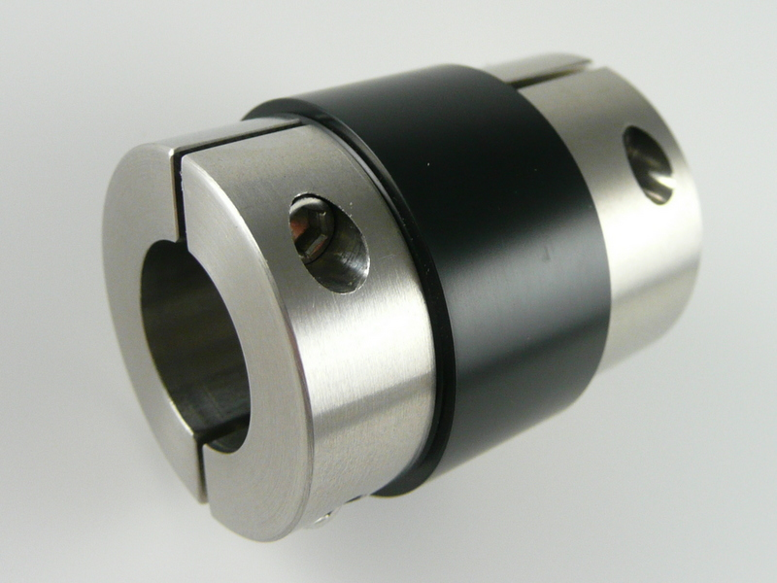
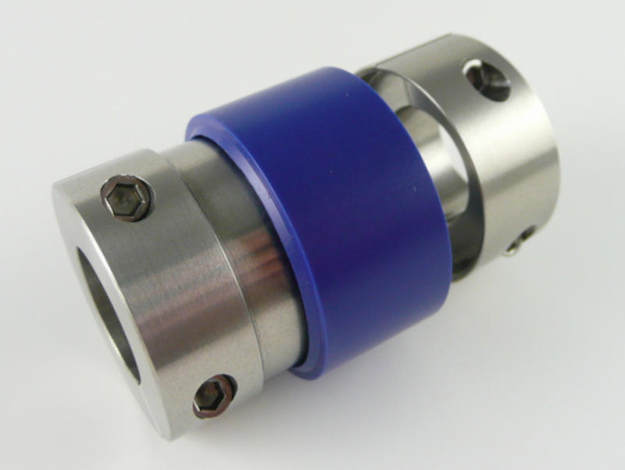
The nylon sleeve is usually placed on the bottom shaft. The nylon sleeve holder is held to the shaft by the 4 x clamping screws.
The design allows the operator to position the holder to any part of the shaft.

There are 2 colours of nylon sleeve. Each colour is better suited for a specific range of stock:
The Black Nylon Sleeve: 65-170 gsm
The Blue Nylon Sleeve: 170-270 gsm

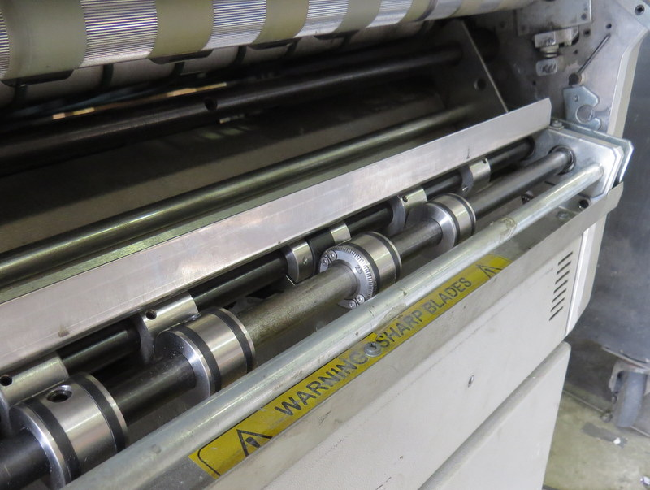
Please note:
The top shaft gripper support collars must be aligned with the original all metal support collars.
Failure to carry out this procedure may result in a loss of straight line perforation control.

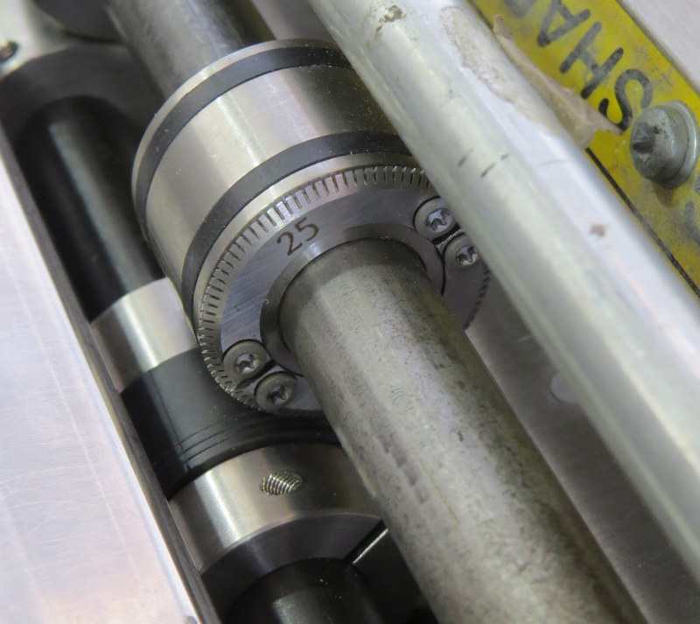
Perforation blade fixed to the gripper support collars with a black nylon sleeve placed directly below.
Helpful advice:
If possible, always try to place the perforation blade over one end of the nylon sleeve.
As the sleeve becomes worn, move the sleeve 0.5mm onto an unused area. This makes it easy to identify when the nylon sleeve needs to be replaced.
Please note:
We cannot guarantee micro-perforation result penetration quality and consistency when more than 1 micro-perforator tool is installed on to the shafts of a Morgana machine at one time.

